Technology Stack (Architecture & Stack)
Date | 26 September 2026
Team ID | SWTID-2026-1610
Project Name | AI Study Buddy
Maximum Marks | 4 Marks

Technical Architecture
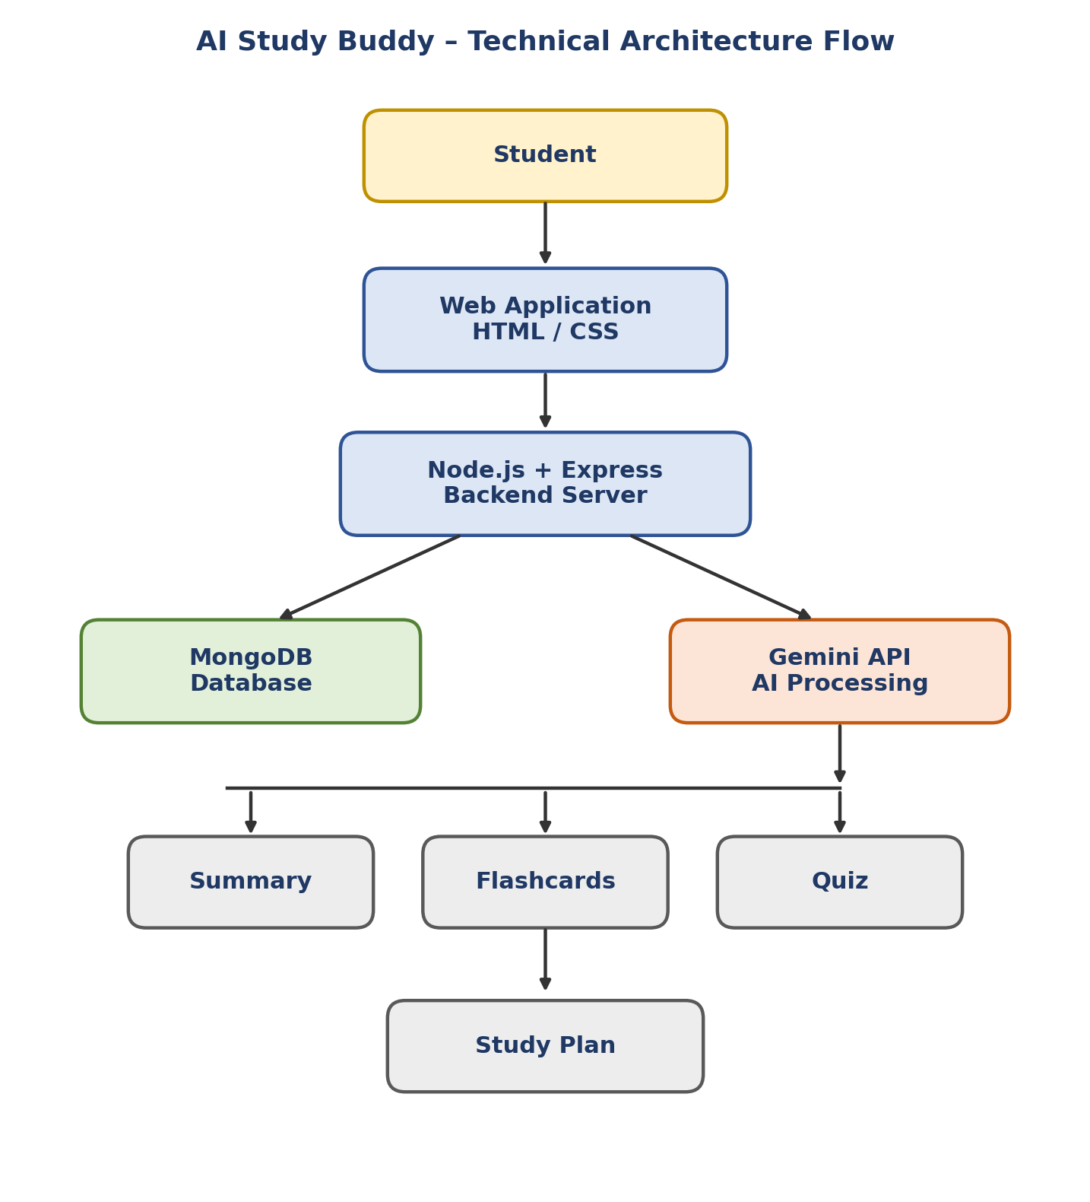

Architecture Description
The AI Study Buddy system follows a client-server architecture. The student interacts with the application through the user interface. The backend is developed using Node.js and Express.js.
The application allows students to upload study materials. The backend processes the uploaded material and stores the required information in MongoDB. The extracted study content is sent to the Google Gemini API for AI processing.
The Gemini API generates useful learning resources such as:
- Summary
- Flashcards
- Quiz
- Personalized Study Plan
Authentication is handled using JWT, and passwords are protected using bcrypt.

Table-1: Components & Technologies
S.No | Component | Description | Technology
1 | User Interface | Provides an interface through which students interact with the application and submit their study materials. | HTML, CSS
2 | Application Logic-1 | Handles user registration, login and authentication. | Node.js, Express.js, JWT
3 | Application Logic-2 | Handles study material upload and PDF text extraction. | Node.js, Express.js, Multer, PDF Parser
4 | Application Logic-3 | Processes study content and generates summaries, flashcards, quizzes and study plans. | Google Gemini API
5 | Database | Stores user details, uploaded material information and application data. | MongoDB, Mongoose
6 | Cloud Database | Cloud database is not used in the current implementation. | Not Applicable
7 | File Storage | Stores uploaded PDF study materials locally during application usage. | Local File System
8 | External API-1 | Generates AI-based learning content from the study material. | Google Gemini API
9 | External API-2 | No second external API is used in the current implementation. | Not Applicable
10 | Machine Learning Model | AI model is used to understand study material and generate learning resources. | Google Gemini
11 | Infrastructure (Server / Cloud) | Application is currently executed on a local development server. | Node.js Local Server

Table-2: Application Characteristics
S.No | Characteristics | Description | Technology
1 | Open-Source Frameworks | Open-source frameworks and libraries are used for backend development and database connectivity. | Node.js, Express.js, Mongoose
2 | Security Implementations | User authentication is implemented using JWT. Passwords are protected using bcrypt. API routes use authentication tokens for access control. | JWT, bcrypt
3 | Scalable Architecture | The backend is organized into separate routes and utility modules, making it easier to add new features and APIs. | Node.js, Express.js, Modular Architecture
4 | Availability | The application runs on a local server and is available whenever the server is running. A future deployment can provide continuous availability. | Node.js Local Server
5 | Performance | The application uses separate API endpoints for different operations such as summary, flashcards, quiz and study plan generation. This keeps the backend operations organized and reduces unnecessary processing. | Express.js, MongoDB, Gemini API

Technology Stack Summary
Layer | Technology Used
Frontend | HTML, CSS
Backend | Node.js, Express.js
Database | MongoDB
Database ODM | Mongoose
Authentication | JWT
Password Security | bcrypt
File Upload | Multer
PDF Processing | PDF Parser
AI Service | Google Gemini API
API Testing | Postman
Development Environment | Visual Studio Code

